CIDM 6356 Detecting Employee Fraud – Digital Forensic Report

Prepared by : Bryan Fudala
Field: Digital Forensics
On Behalf of: West Texas A&M University
Subject Matter: POS Fraud Detection

Summary Of Analysis

A digital forensic analysis was conducted to detect fraudulent activity for a retail company. The main objective was to conduct an audit on customer returns and determine if fraudulent activity is present along how to identify future activity. Upon discovery, analysis determined that employee Mark Moore-ID: 7857 was responsible for committing financial fraud by crediting 2 credit card numbers while a receipt wasn’t present and while a gift card was initially used. This resulted in $4172.98 of fraudulent activity spanned across 68 Fraudulent Transactions. This finding constitutes fraudulent activity since out of every employee, there was only 1 identified employee who used 2 card number ID’s to credit a return for multiple return transactions. Policy Violation was discovered among Employees Mark Moore, John Mason, and Anthony West; but only employee Mark Moore was flagged for fraudulent activity.
Objectives

As an auditor, I was provided with a transactional database containing transactional data pertaining to each distinct return along with a record of employee information. The following objectives are as follows:
- Perform an audit to find any potential fraud in customer returns by adhering to 3 guiding principles
  - Obtaining the details of what happened with the store data and identifying red flags
  - Building an analytical model to discover those red flags
  - Running the analytical model on unknown data.
- Perform an audit to find any improper procedure violations in customer returns.

Chain of Custody
The Original files were extracted from the google drive location : https://drive.google.com/file/d/1OYrYPNV-bHp23hUl_8a7a_tN7cZoNGvi/view?usp=sharing. The single file were then extracted onto a local hard drive on 02/05/2024. This is a database file that is compatible with SQL applications. In order to validate the authenticity of the file and the correlating Hash number, a Checksum analysis was conducted using windows Powershell. The file path was entered through the command line using the “Get-FileHash” command which uses the SHA256 algorithm. This analysis was conducted on 02/27/2024. The database file was confirmed to be legitimate in terms of origin. (Screenshot 0A) confirms the hash number equates to the hash number originally provided. Since the file integrity was confirmed legitimate, it can be inferred that no further alterations were made to the database. From this point forward I further assessed the data dictionary of the main tables within the database to determine how the data is processed along with each candidate Key (Screenshot 0B & Screenshot 0C). From this point forward, I proceeded to use DB SQL Lite to conduct my analysis and record the findings.
(Screenshot 0A). Confirming Hash Number of database file
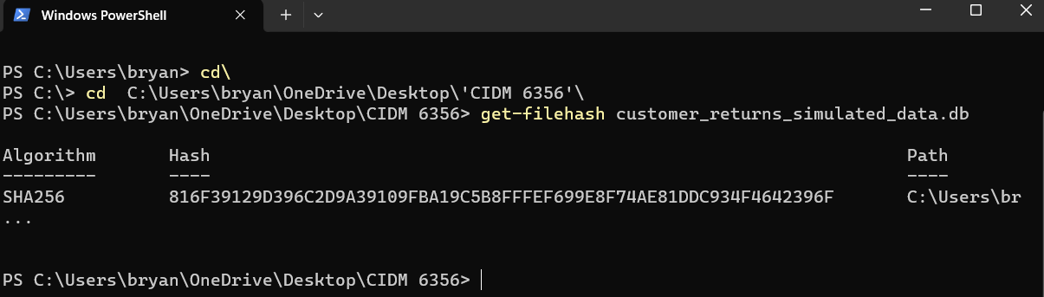

Screenshot 0B). Analysis of the structure of the database
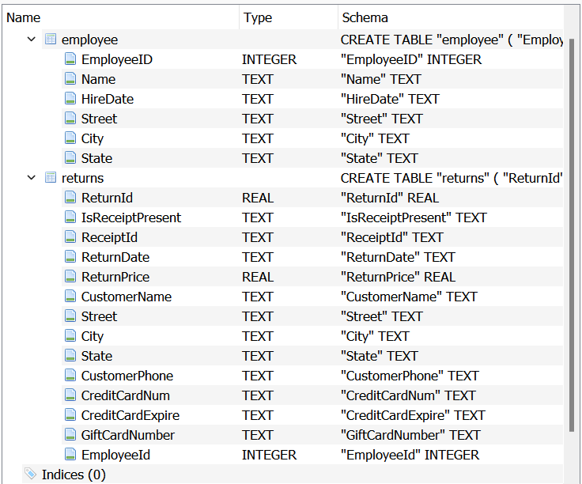
Methods And Tools

The methodology that was used adhered to Aaren Humphrey’s 3-step process for identifying fraudulent activity. The following steps below indicate the sequential processes that took place in order meet the objectives detailed earlier.
- Extract files from google drive to a local CPU/Drive and placing files in a designated folder
  - https://drive.google.com/file/d/1OYrYPNV-bHp23hUl_8a7a_tN7cZoNGvi/view?usp=sharing
- Open up Windows Powershell command prompt and proceed with these steps:
  - Change command line to newly designated folder containing db file
  - Enter in the code “Get-FileHash” followed by the file name string of each file
    - This will return the Hash number for the intended file
  - Record the hash number extracted from powershell and compare it to the original hash number provided within the db file titled “customer_returns_simulated_data.db”
  - If the Hash numbers match, this determines the file is authenticated.
- Opening up DB Browser for SQLite
  - Loading the database “customer_returns_simulated_data.db”
  - Saving the workspace as a project to reflect on findings and code that was used.
  - The database contained 2 tables “Employee” and “Returns” which were briefly analyzed using the “Browse” function within the application.
- Obtaining the Details of what happened with the data and identifying any potential red flags. Analytical model built around the policy violation of when a credit card is used when no receipt is present.
  - Ran queries on the main transactional table “Returns” in order to identify anything that stands out as a potential red flag.
  - Checked to see if a receipt was used, but no receipt ID recorded.
    - No records Found which means no fraudulent activity when recording receipt data.
    - SQL Code below
      - /*Check to see if Receipt exists without id*/
      - Select *
      - From returns
      - Where IsReceiptPresent = 'True' and ReceiptID is Null
      - Limit 10
  - Checked to see if both Credit card and gift card were simultaneously used.
    - No records Found which means no fraud activity of duplicating credit to recipient.
    - SQL Code below
      - /*Check to see if credit card and gift card were both given funds*/
      - Select *
      - From returns
      - Where CreditCardNum is not null and GiftCardNumber is not null
      - Limit 10
  - Checked to see if any gift card ID’s are duplicated and used more than once.
    - No records Found which means no fraud in the terms of applying credit on a single card number multiple times.
    - SQL Code below
      - /*check to see if any gift card ID'ss are duplicated*/
      - Select GiftCardNumber, count(GiftCardNumber) as countgiftnumber
      - from returns
      - group by GiftCardNumber
      - order by countgiftnumber DESC
  - Checked to see if any of the Return ID’s had multiple entries in duplication.
    - No records found which means no fraud in terms of duplicating a return thru re-use of a single Return ID.
    - SQL Code Below
      - /*check to see if any return ID'ss are duplicated*/
      - Select ReturnId, count(returnid) as countreturn
      - from returns
      - group by returnid
      - order by countreturn DESC
  - Checked to see if any of the receipt ID’s had multiple entries in duplication.
    - No records Found which means no fraud when duplicating Receipt ID’s to apply credit to a party.
    - SQL Code below
      - /*check to see if any receipt ID'ss are duplicated*/
      - Select ReceiptId, count(ReceiptId) as countreceiptid
      - from returns
      - group by ReceiptId
      - order by countreceiptid DESC
  - Checked to see if a receipt isn’t present but a credit card was used.
    - RED FLAG IDENTIFIED – 85 records identified. This is a store violation as well.
    - (Screenshot 4F)
    - SQL Code below
      - /* Check to see if receipt isn't present but credit applied to credit card*/
      - Select *
      - From returns
      - where IsReceiptPresent = 'False' and GiftCardNumber is null
      - limit 10
  - Reconfirmed the original red flag finding of credit card use when no receipt is present.
    - The same 85 records were identified as before.
    - SQL Code Below
      - . /* reconfirmed last hypothesis and it results in the same 85 records*/
      - Select *
      - From returns
      - where IsReceiptPresent = 'False' and CreditCardNum is not NULL
  - Checked to determine if an employee address equals CC card address.
    - No records found which means Employees are not crediting Money to themselves directly.
    - SQL Code Below.
      - /* 2. checking to see if transaction address is equal to an employee address*/
      - Select *
      - From returns
      - left join employee on employee.Street = returns.Street
      - where employee.employeeid is not null
  - Checked to see if an employee’s hire date is past the transactional date.
    - No Records Found which means there isn’t fraudulent activity with creating fake employees on the employee Roster.
    - SQL Code below
      - /* 2. checking to see if employee's hire date is greater than return date per trans*/
      - Select *
      - From returns
      - left join employee on employee.HireDate > returns.ReturnDate
      - where employee.employeeid is not null
  - Analyzed how any customers have more than 1 return associated with their name.
    - Only 12 records found, but doesn’t indicate any correlation with fraudulent activity since record count is minimal.
    - (Screenshot 5D)
    - SQL Code Below
      - /* Checking to see how many customers have more than 1 return*/
      - Select CustomerName, count(returnid) as returncount
      - From returns
      - group by CustomerName
      - order by returncount desc
  - Analyzed how many customers had more than 1 interaction with a specific employee.
    - Only 1 employee found, no indication was found linking this employee to fraudulent activity since record count is minimal.
    - (Screenshot 5E)
    - SQL Code below
      - /* Checking to see if customers had multiple transactions with single employee*/
      - Select CustomerName, employeeid, count(returnid) as returncount
      - From returns
      - group by CustomerName, employeeid
      - order by returncount desc
  - Determined which employees processed credit without a receipt evident.
    - 3 Employees discovered with multiple events of transaction processing.
    - (Screenshot 5F)
    - SQL Code Below
      - /* Checking to see which employees processed credit without receipt*/
      - Select employeeID, count(returnID) as fraudcounts
      - From returns
      - where IsReceiptPresent = 'False' and CreditCardNum is not NULL
      - group by employeeID
      - order by fraudcounts desc
  - Analyzed if any credit cards were used twice thru out the transactional history.
    - Out of all the total transactions, only 2 credit card numbers were found with multiple transaction history.
    - (Screenshot 5G)
    - SQL Code below.
      - /* Checking to see if credit cards were used twice per multiple transactions*/
      - Select CreditCardNum , count(returnID) as cardcount
      - From returns
      - where creditcardnum is not null
      - group by CreditCardNum
      - order by cardcount desc
  - Analyzed what credit cards were used per each employee
    - Fraudulent Activity pinpointed per employee which aligns with results found in 5G.
    - (Screenshot 5H).
    - SQL Code below.
      - /* Checking to see which credit cards were used per each employee*/
      - Select EmployeeId, CreditCardNum , count(returnID) as cardcount
      - From returns
      - where creditcardnum is not null
      - group by EmployeeId, CreditCardNum
      - order by cardcount desc
- Ran analytical models that would be applicable for any unknown data or foreseeable data to detect Fraud or misconduct.
  - Created and ran a standardized query to identify any potential red flags in the foreseeable future based on the results found in prior. Identifies employee ID’s not adhering to credit card/receipt guidelines and procedures.
    - (Screenshot 6A)
    - SQL Code Below
      - */ Detecting employees who are violating policy
      - Select Distinct EmployeeID
      - From returns
      - Where IsReceiptPresent = ‘False’ and GiftCardNumber is null
      - Limit 10
  - Created and ran a model to detect employees engaging in fraudulent activity as discovered using multiple credit card numbers of the same credit card id
    - (Screenshot 6B)
    - SQL Code Below
      - /* Creating model to find employees who are using fraudulent card multiple times */
      - Select EmployeeId, CreditCardNum , count(returnID) as cardcount
      - From returns
      - where CreditCardNum is not null
      - group by employeeid, CreditCardNum
      - having cardcount>1
      - order by cardcount desc

(Screenshot 4F) 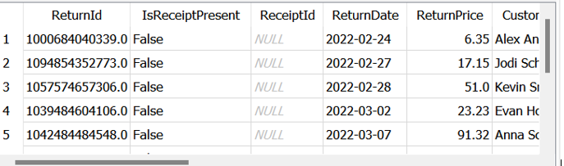
(Screenshot 5D) 
(Screenshot 5E) 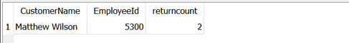
(Screenshot 5F) 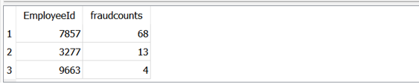
(Screenshot 5G) 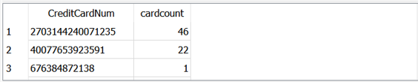
(Screenshot 5H) 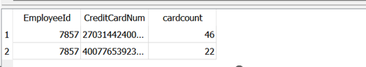
(Screenshot 6A) 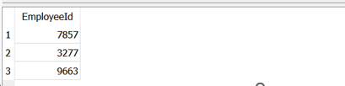
(Screenshot 6B) 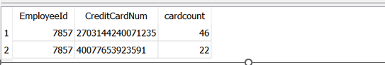

Relevant Findings

- Upon conducting the initial search determining red flags, there were not any database integrity issues discovered within the database itself, duplicated candidate keys, nor were there any events of missing data.
- The big red flag was discovered upon running queries to see if there were any instances of policy violation. This would be where a receipt was not present, but refund was attributed to the credit card and not store credit. Definitionally speaking this would be policy violation.
  - The Policy violation query narrowed down the analysis to look at instances associated strictly with credit card fraud.
- No indication of employees using their personal address as a transaction or transactions taking place before the employee’s hire date were found.
- Upon analyzing how many customers were in the database with only more than 1 return, there were only 12 discovered.
  - This indicates that Fraudulent activity would most likely not be linked to the customer name being involved in the fraudulent activity
- When analyzing if there were multiple customer interactions with a single employee only 1 record was found
  - This indicates that it’s highly unlikely that fraudulent activity is taking place between the customer and an employee.
- Upon analyzing which credit cards were used more than once per the entire database, it was discovered that there were only 2 credit card numbers that had multiple transactions at that store location. (Screenshot 5G)
  - This indicates that it’s a rarity if a customer processes a return more than once at this store location using that same card twice.
  - Furthermore, the 2 credit cards used more than once were attributed to 1 single employee id that did not follow store policy.
  - These 2 credit card numbers were used in reference of a policy violation of an employee crediting a return while no receipt was present and when a gift card was used at the POS.
  - One respective card ID was used 46 times, while the other was used 22 times.
- Although there were 3 total employees who did not abide by compliance of processing a no-receipt return by refund of credit card, 2 of the employees had no indication of fraudulent activity, while 1 employee with employee Mark Moore – ID: 7857 did commit fraudulent activity thru analysis.
  - These 2 specific employees more than likely did not know of the store’s guidelines since there was no other red-flag instances found to tie back to those specific employee John Mason - ID: 3277 and Employee Anthony West-ID 9663
  - Employee John Mason:3277 and Employe Anthony West: ID 9663, did not use the same credit card number for multiple return transactions as did employee Mark Moore: ID 7857.
- Going forward, it is safe to assume that the 2 models used (Screenshot 6A & 6B) can be used to detect future fraudulent activity based on the results and analysis of the forensic report.

